***IPL MATCH ANALYSIS***

1. Which team had won the match and the toss more times?

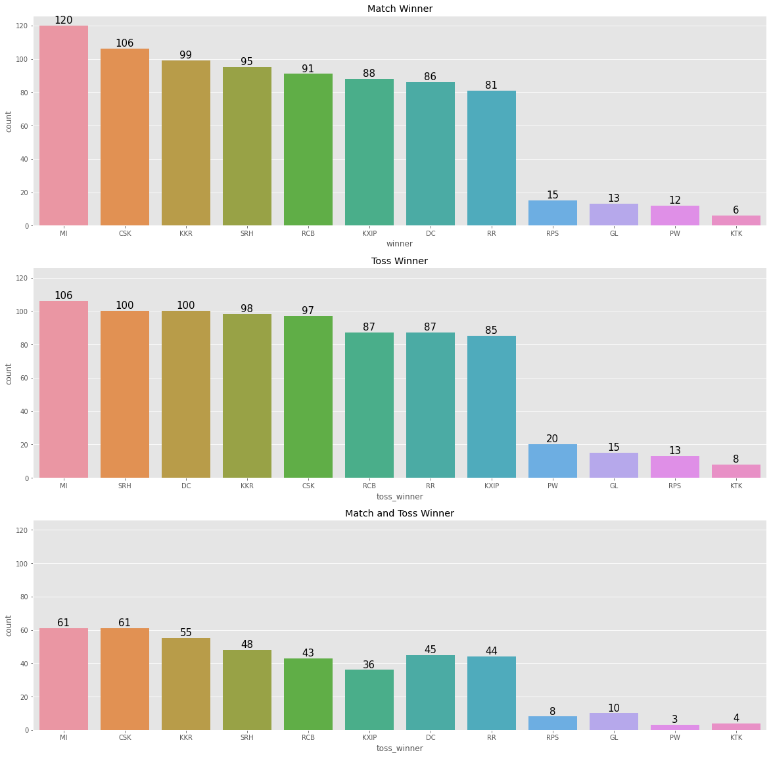

* MI had won the Highest matches among the other team
* MI had won the Highest toss compare to the other team
* But the winning of the both Match and Toss ,MI is equal to CSK and nearly to KKR.

1. What was toss decision of the toss Winning teams?

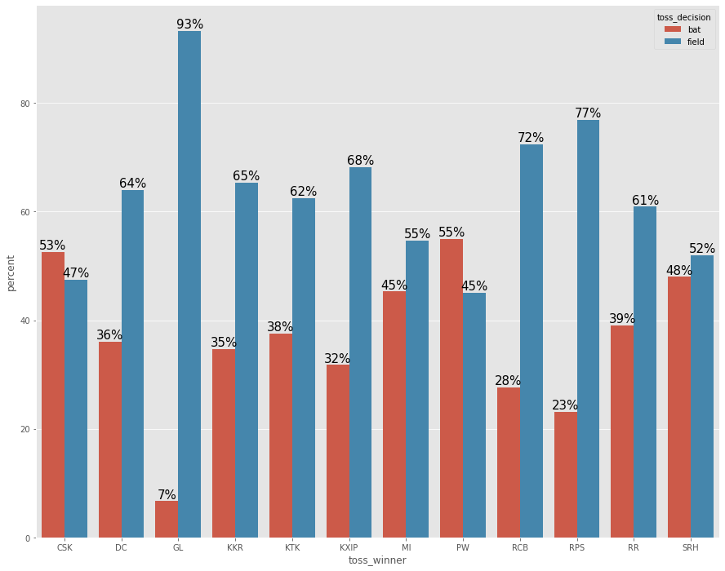

* SRH,CSK,MI,PW are the only team who had chosen bat and field nearly equally.

1. Which team won the match based their toss decision?

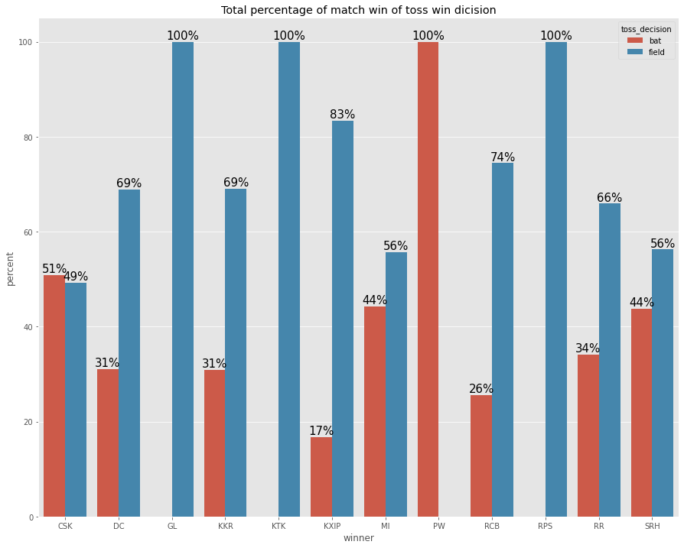

* There are mainly two Team who had won the match 100% when they choose Field.(GL,KTk)
* There is a Team who had won the match 100% when they choose Bat.(PW)
* KXIP,RCB had won more matches when they selected Field.(High Probability of match winning if toss decision is field)
* MI,SRH,CSK is Very consistent Team (There is no difference is they won or loss the Toss.)

|  |  |  |  |
| --- | --- | --- | --- |
| Team | Match | Wins | WP |
|  |  |  |  |
| MI | 203 | 120 | 59.11 |
| SRH | 199 | 106 | 53.27 |
| RCB | 195 | 99 | 50.77 |
| DC | 194 | 95 | 48.97 |
| KKR | 192 | 91 | 47.4 |
| KXIP | 190 | 88 | 46.32 |
| CSK | 178 | 86 | 48.31 |
| RR | 161 | 81 | 50.31 |
| PW | 46 | 15 | 32.61 |
| GL | 30 | 13 | 43.33 |
| RPS | 30 | 12 | 40 |
| KTK | 14 | 6 | 42.86 |

## Final conclusion of match winning